🏢 10 Condo Addresses
- UrbanVista Tower 1, 888 Aurora Blvd, Quezon City, Metro Manila
- UrbanVista Residences, 21 Bayview St., Pasay City, Metro Manila
- UrbanVista Heights, 5 Jupiter St., Makati City, Metro Manila
- UrbanVista Green, Katipunan Ave., Loyola Heights, Quezon City
- UrbanVista Prime, 77 Pioneer St., Mandaluyong City
- UrbanVista Oasis, 12 Sucat Road, Parañaque City
- UrbanVista Skyline, 1342 EDSA cor. Shaw Blvd., Mandaluyong
- UrbanVista Parklane, 19 Commonwealth Ave., Quezon City
- UrbanVista Central, 47 Mabini St., San Juan City
- UrbanVista Ridge, 86 Ortigas Ave., Pasig City

10 General Descriptions
🏢 1. UrbanVista Tower 1 – Quezon City
UrbanVista Tower 1 offers a perfect balance between urban convenience and serene living. Located along Aurora Boulevard, it gives residents easy access to LRT-2, major universities, and lifestyle centers. With its secure environment, modern amenities, and thoughtfully planned studio units, Tower 1 is ideal for young professionals and students who value accessibility without sacrificing comfort.

🏢 2. UrbanVista Residences – Pasay City
Nestled near Manila Bay, UrbanVista Residences combines a coastal ambiance with city convenience. This mid-rise development features resort-style amenities such as a pool, fitness gym, and a garden lounge area. It's perfect for families and individuals who want to come home to a relaxed environment just minutes away from MOA, airports, and business districts.

🏢 3. UrbanVista Heights – Makati City
Standing tall in the heart of Makati’s commercial zone, UrbanVista Heights is designed for modern urbanites who want luxury, style, and convenience. It features high-end interiors, smart home-ready units, and sky lounge areas with panoramic views of the city skyline. This tower is tailored for professionals working in the CBD and those with refined tastes.

🏢 4. UrbanVista Green – Loyola Heights, QC
UrbanVista Green promotes sustainable and eco-friendly living. Located near Katipunan, it features solar-lit pathways, vertical gardens, and a green roof deck. Residents enjoy the calming atmosphere with accessibility to top schools like Ateneo and Miriam College. A perfect spot for families and students seeking a balance between nature and city life.

🏢 5. UrbanVista Prime – Pioneer St., Mandaluyong
UrbanVista Prime is a premium development located at the heart of Mandaluyong. With spacious 1- and 2-bedroom units, this residence offers flexible layouts suitable for growing families or shared accommodations. The development includes a co-working space, indoor lounge, children’s play area, and rooftop garden, making it a self-contained community in the middle of the city.

🏢 6. UrbanVista Oasis – Parañaque City
Designed as a peaceful hideaway in the south, UrbanVista Oasis offers the feeling of being on vacation year-round. Just a few minutes from Sucat interchange, this gated condo complex features Mediterranean-inspired architecture, lush landscapes, and wellness-centered amenities like yoga spaces and an outdoor meditation deck.

🏢 7. UrbanVista Skyline – EDSA Shaw Blvd.
A towering presence along EDSA, UrbanVista Skyline stands as a hub for high-rise living. Designed for urban professionals, this development provides direct access to MRT stations and nearby business hubs. It boasts of premium amenities like a rooftop bar, infinity pool, and automated entry systems for a truly cosmopolitan lifestyle.

🏢 8. UrbanVista Parklane – Commonwealth Ave.
UrbanVista Parklane offers a spacious and family-friendly environment in the bustling area of Commonwealth. The units are thoughtfully designed with generous living spaces and natural lighting. The property includes open parks, jogging trails, and pet-friendly zones, catering to the lifestyle needs of families who prefer suburban comforts without moving too far from Metro Manila.

🏢 9. UrbanVista Central – San Juan City
In the quaint neighborhood of San Juan lies UrbanVista Central — a boutique condominium that blends exclusivity with convenience. Its low-density design ensures privacy and peace, while its proximity to Greenhills and Ortigas allows residents to access commercial and leisure destinations within minutes. It is ideal for those who prefer a quiet, central location with upscale amenities.

🏢 10. UrbanVista Ridge – Ortigas Ave., Pasig City
UrbanVista Ridge offers elevated city living for discerning homeowners. Located near Ortigas Center, this high-rise tower provides stunning views of the Pasig River and city skyline. Its units are crafted with premium finishes and come in a variety of layouts. Residents benefit from hotel-style services, a business center, and full-service concierge, making every day feel like a five-star experience.

📰 10 Blog Titles + Brief Summary
- Why UrbanVista is Perfect for First-Time Buyers – Tips and perks for first-time homebuyers.
Buying your first home can be overwhelming—but UrbanVista makes it easier than ever. With flexible payment plans, low down payments, and accessible locations near key city spots, first-time buyers can finally enjoy premium condo living without breaking the bank. Plus, the welcoming community and 24/7 security give you the peace of mind you deserve.
- 5 Things to Consider Before Moving to a Condo – A checklist to help you make the move smoother.
Thinking of making the switch to condo living? We’ve rounded up the top five must-knows before the move. From checking building amenities to planning your storage, UrbanVista supports your transition with guided walkthroughs, pre-move inspections, and a dedicated homeowner hotline.
- Condo vs. House: Which is Right for You? – Weighing pros and cons for better decision-making.
Still torn between a condo or a traditional house? This blog breaks it down—costs, maintenance, accessibility, and lifestyle. UrbanVista offers the convenience of modern condo living with community spaces, security, and prime locations, making it a smarter, low-maintenance alternative to detached homes.
- How to Maximize Space in a Studio Unit – Creative solutions for making the most of small spaces.
- Amenities That Matter: What Buyers Look For – Guide on what features raise condo value.
- Location Matters: Why Metro Manila is Still Prime – Real estate trends and strategic locations.
- Pet-Friendly Condo Living: Is It Possible? – Rules and tips for owning pets in your unit.
- The Rising Trend of Smart Condos in PH – A look into home automation and smart features.
- Home Office in a Condo: Tips for Productivity – How to create a productive space at home.
- UrbanVista’s Commitment to Green Living – Sustainability efforts in our condo designs.
REVIEW
1. 🏡 "I never imagined owning a unit this stylish and affordable. UrbanVista made it happen!" – Jessa, 27, first-time homeowner
2. 📦 "UrbanVista’s move-in checklist was a lifesaver. Everything was smooth and stress-free!" – Luis, 33
3. 🏙️ "With my busy schedule, condo living is a dream—no yard work, just pure comfort." – Anna, 30, entrepreneur
4. 🪑 "I followed UrbanVista’s design tips and my place now feels twice as big!" – Marco, 25, graphic designer
5. 🏋️ "The gym, sky lounge, and WiFi zones? A total win for work-life balance!" – Bianca, 32, freelancer
6.📍 "Everything I need is just 10 minutes away—UrbanVista nailed the location!" – Ryan, 29, call center supervisor
7.🐶 "Finding a condo that allows pets was tough—thank you, UrbanVista!" – Claire, 34, furmom of two
8. 🔐 "I control my lights and door from my phone—UrbanVista is future-ready!" – Derek, 31, IT specialist
9. 💻 "My condo home office is so comfy, I never miss the office!" – Lara, 28, remote content writer
10. 🌱 "It feels good to live in a place that truly cares about the environment." – Neil, 35, environmental consultant

<!DOCTYPE html>
<html lang="en">
<head>
<meta charset="UTF-8" />
<meta name="viewport" content="width=device-width, initial-scale=1" />
<title>3-Card Carousel</title>

<!-- Bootstrap 5 CSS -->
<link href="https://cdn.jsdelivr.net/npm/bootstrap@5.3.0/dist/css/bootstrap.min.css" rel="stylesheet" />

<style>

</style>
</head>
<body>

<!-- Button to trigger modal -->
<button type="button" class="btn btn-primary" data-bs-toggle="modal" data-bs-target="#reviewModal">
View Blog + Reviews
</button>

<!-- Modal -->
<div class="modal fade" id="reviewModal" tabindex="-1" aria-labelledby="reviewModalLabel" aria-hidden="true">
<div class="modal-dialog modal-lg modal-dialog-centered modal-dialog-scrollable">
<div class="modal-content p-4">
<div class="modal-header">
<h5 class="modal-title" id="reviewModalLabel">REVIEWS</h5>
<button type="button" class="btn-close" data-bs-dismiss="modal" aria-label="Close"></button>
</div>

<div class="modal-body">

<!-- Reviews Carousel -->
<div id="reviewCarousel" class="carousel slide mt-4" data-bs-ride="carousel" data-bs-interval="3000">
<div class="carousel-inner">

<!-- Review 1 -->
<div class="carousel-item active">
<div class="border p-3 rounded bg-light">
<div class="d-flex justify-content-between align-items-center">
<strong>Luis, 33</strong>
<span class="text-muted small">3 minutes ago</span>
</div>
<p class="mt-2">"UrbanVista’s move-in checklist was a lifesaver. Everything was smooth and stress-free!"</p>
<div class="text-warning fs-5">★★★★☆</div>
</div>
</div>

<!-- Review 2 -->
<div class="carousel-item">
<div class="border p-3 rounded bg-light">
<div class="d-flex justify-content-between align-items-center">
<strong>Jessa, 27</strong>
<span class="text-muted small">10 minutes ago</span>
</div>
<p class="mt-2">"Perfect for first-time buyers. It felt like they were guiding me every step of the way."</p>
<div class="text-warning fs-5">★★★★★</div>
</div>
</div>

<!-- Review 3 -->
<div class="carousel-item">
<div class="border p-3 rounded bg-light">
<div class="d-flex justify-content-between align-items-center">
<strong>Marco, 25</strong>
<span class="text-muted small">22 minutes ago</span>
</div>
<p class="mt-2">"Smart space tips helped me arrange my studio like a pro!"</p>
<div class="text-warning fs-5">★★★★☆</div>
</div>
</div>

</div>

<!-- Carousel Controls -->
<button class="carousel-control-prev" type="button" data-bs-target="#reviewCarousel" data-bs-slide="prev">
<span class="carousel-control-prev-icon" aria-hidden="true"></span>
<span class="visually-hidden">Previous</span>
</button>
<button class="carousel-control-next" type="button" data-bs-target="#reviewCarousel" data-bs-slide="next">
<span class="carousel-control-next-icon" aria-hidden="true"></span>
<span class="visually-hidden">Next</span>
</button>
</div>
</div>

<div class="modal-footer">
<button type="button" class="btn btn-secondary" data-bs-dismiss="modal">Close</button>
</div>
</div>
</div>
</div>

<!-- Bootstrap 5 JS bundle -->
<script src="https://cdn.jsdelivr.net/npm/bootstrap@5.3.0/dist/js/bootstrap.bundle.min.js"></script>

</body>
</html>

💰 10 Price Lists (Sample Units)
Condo Name | Unit Type | Price (PHP) | Monthly (5 yrs)
UrbanVista Tower 1 | Studio (25sqm) | 2,100,000 | ₱35,000/month
UrbanVista Residences | 1-BR (40sqm) | 3,500,000 | ₱58,300/month
UrbanVista Heights | 2-BR (60sqm) | 5,000,000 | ₱83,300/month
UrbanVista Green | Studio | 2,200,000 | ₱36,600/month
UrbanVista Prime | 1-BR | 3,700,000 | ₱61,600/month
UrbanVista Oasis | 2-BR | 4,800,000 | ₱80,000/month
UrbanVista Skyline | Studio | 2,300,000 | ₱38,300/month
UrbanVista Parklane | 1-BR | 3,600,000 | ₱60,000/month
UrbanVista Central | 2-BR | 5,200,000 | ₱86,600/month
UrbanVista Ridge | 1-BR | 3,800,000 | ₱63,300/month

Would you like this saved as a downloadable .txt, .csv, or HTML file?

AMENITIES
AMENITIES DESCRIPTION IN HOMR PAGE:
Exceptional Amenities for Elevated Living
Experience a lifestyle of comfort and convenience with our world-class amenities. From a refreshing pool and fully-equipped gym to serene gardens and entertainment spaces, everything you need is right at your doorstep. Live, relax, and thrive in a community designed with you in mind.
AMENITIES DISPLAY BLOCK QUOTES
Sure! Here are 30 popular amenities commonly found in a single condominium building:
- Swimming pool
- Fitness gym
- Sauna or steam room
- Basketball court
- Tennis court
- Jogging track
- Children's playground
- BBQ area or picnic pavilion
- Function room or multi-purpose hall
- Lounge or residents’ clubhouse
- 24/7 security with CCTV
- Concierge or reception area
- Parking garage or basement parking
- Garden or landscaped park
- Reading room or library
- Movie or screening room
- Business center or co-working space
- Bicycle parking/storage
- Pet-friendly area or dog park
- Convenience store or mini-mart
- Laundry room or dry-cleaning service
- Elevator access
- Wi-Fi zones in common areas
- Meditation or yoga room
- Outdoor terrace or rooftop garden
- Party room or karaoke room..
- Mailroom or parcel delivery lockers
- Game room (e.g., billiards, table tennis)..
- Water feature or decorative pond..
- Daycare or childcare center..
Want me to help you organize these or describe each amenity?
LOCATIONS:
Triovista’s PRIME Locations
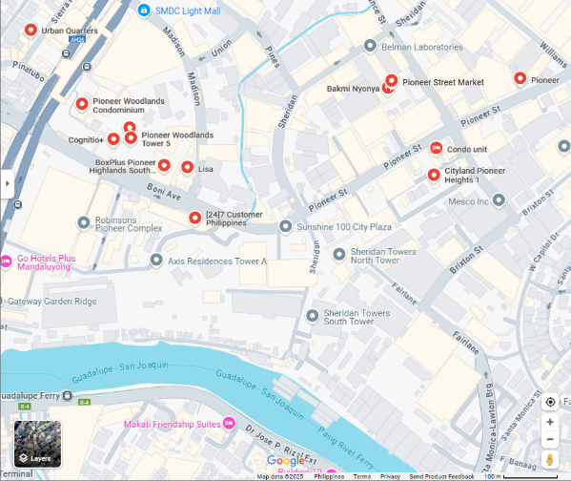
Live where it matters most. Triovista condominiums are perfectly positioned in the heart of the city—offering unmatched access to workplaces, schools, lifestyle hubs, and transport terminals. Enjoy modern living with the convenience of everything just steps away.
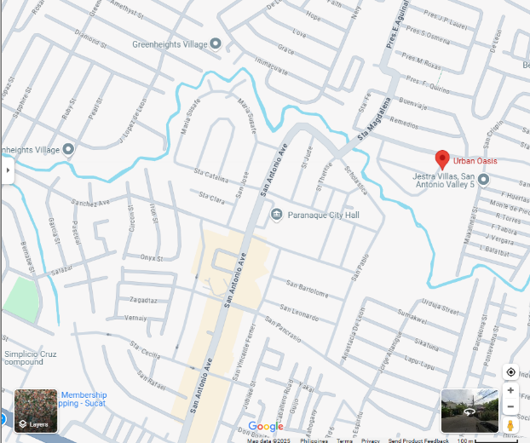
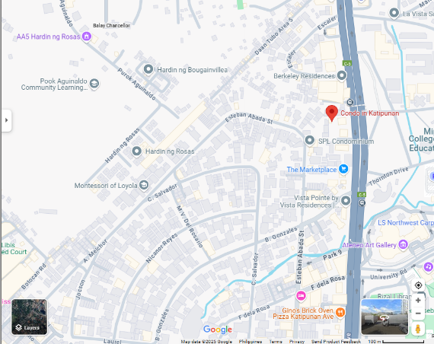
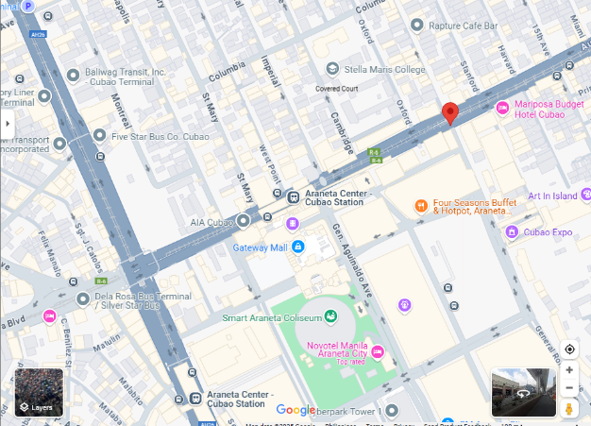
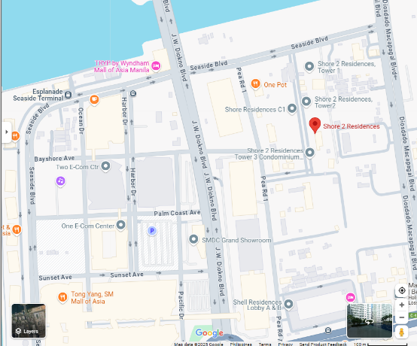
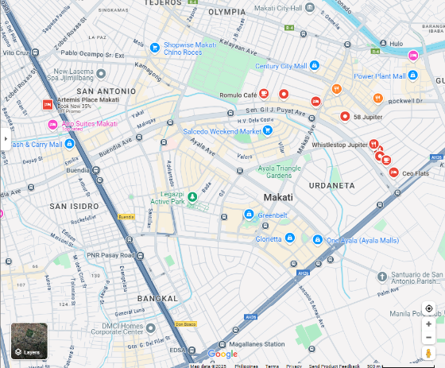

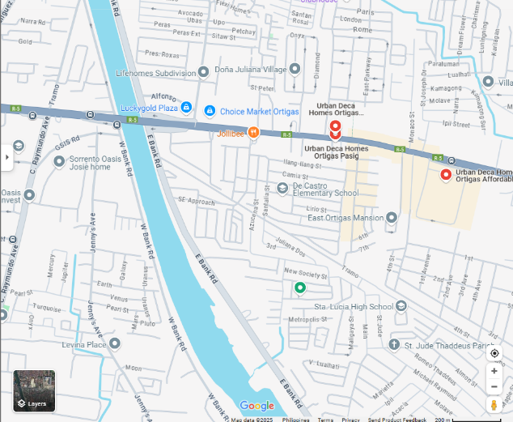
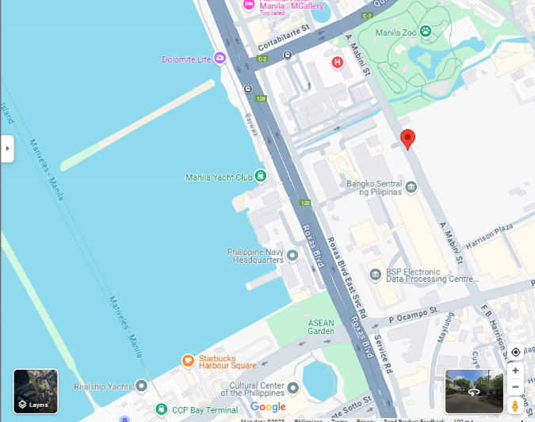
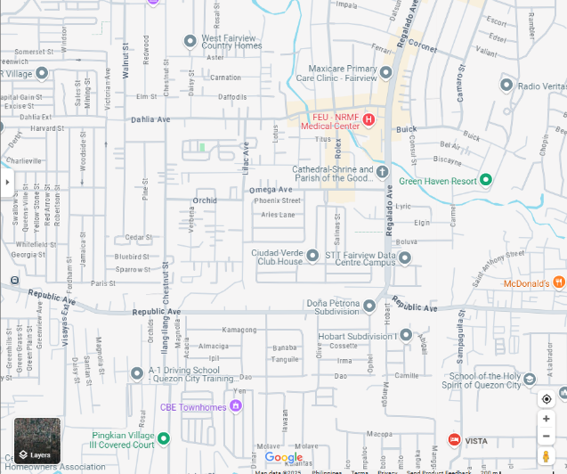
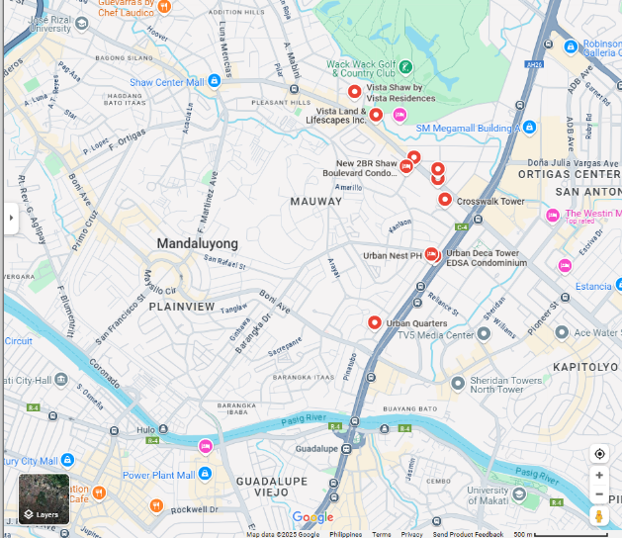

About Triovista

ABOUT
At Triovista, we believe your home should offer comfort, style, and convenience. As a trusted name in modern condominium living, we build thoughtfully designed communities in prime city locations—blending elegant architecture, quality amenities, and smart planning.
Whether you’re starting fresh or investing for the future, Triovista is here to bring you home—where everything begins.

